Self:
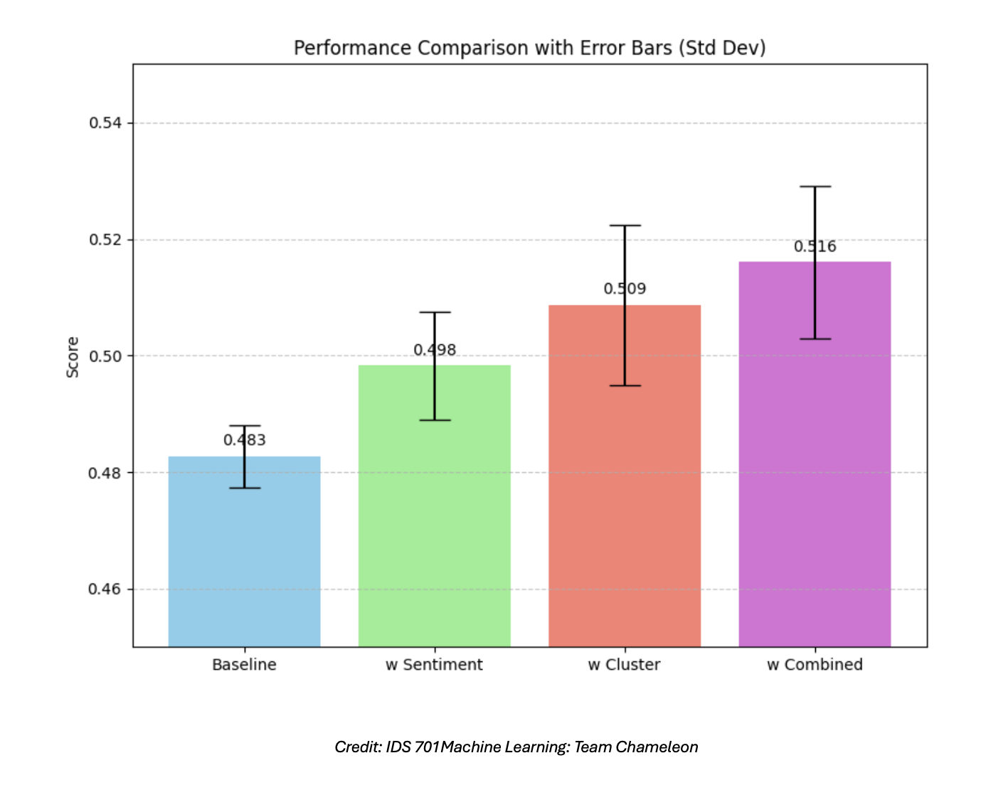
After running multiple iterations (i.e. ~10) of the models we developed, we noticed that not not only is the combined model better on average but when we account for uncertainty, it still consistently outperforms the other models as seen above. This shows that it consistently outperforms the other models, making the case for the combined approach very strong.

Research paper:
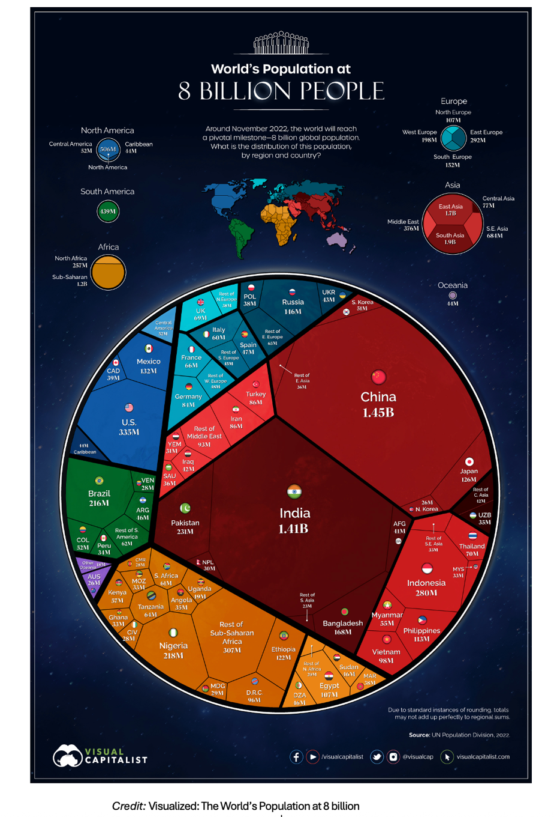

- Simplicity and effectiveness
- Circle = earth (easy to visualize)
- Continents are divided by color and lines separate countries
- Size = population count

